Sevier County Community Emergency Response Team (CERT)

Standard Operating Guidelines

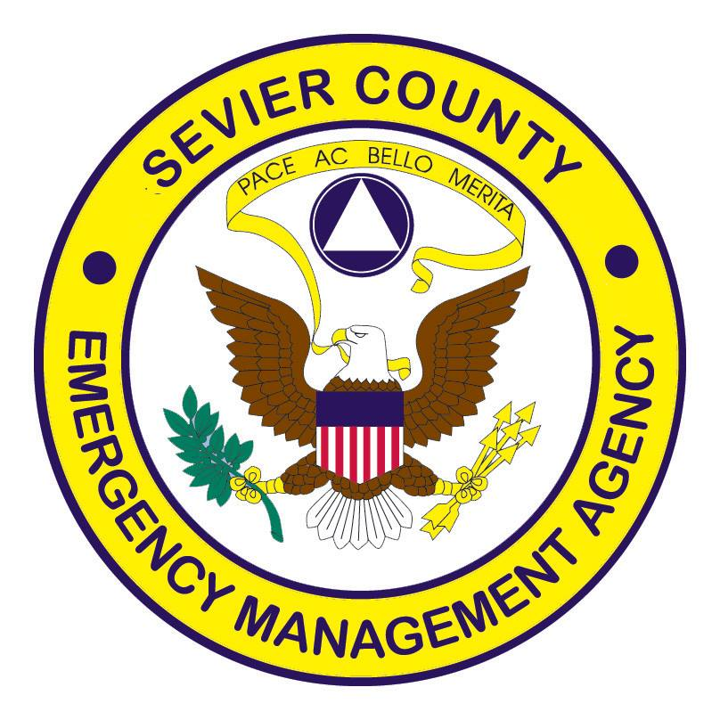

Table of Contents

History of CERT ……………………………………………………………………………………………………………………………………….3
Overview….………………………………………………………………………………………………….………………………….……….….….4
Mission…………………………………………………………………………………………………………………………………….………….….5
Goal……………………………………………………………………………………………………………………………….….……….5
Application Process………………………………………………………………………………………………………………………………….6
Organization Structure………………………………………………………………………………………………………….…………….….7
Training…………………………………………………………………………………………………………………………………….……….…...8
Equipment……………………………………………………………………………………………….………………………………….……….….9
Operation and Communication………………………………………………………………………….………………………………….10
Notifications………………………………………………………………………………………………………………………………………….11
Uniforms…………………………………………………………………………………………………….………………………………………….12
Social Media Policy………………………………………………………………………………………………………………………………..13
Social Media pt.2………………………………………………………………………………………………………………………14
Grounds of Removal…………………………………………………………………………………………………………………………...…15
Code of Conduct……………………………………………………………………………….……………………………………………………16
Standard Operating Guideline Contract…………………………………………………………………………………………………17

History of CERT
The idea behind CERT was developed and implemented by the Los Angeles City Fire Department in 1985. In 1987, the Whittier Narrows earthquake once again confirmed the importance of trained civilians who are able support first responders to meeting their communities’ immediate needs. Following September 11, 2001, the Federal Emergency Management Agency (FEMA) nationalized the Los Angeles Fire Department’s program creating a training curriculum to help communities around the country train CERT volunteers.
The Los Angeles Fire Department developed the CERT Program after examining the civilian response to disasters in Mexico and Japan in 1985. The LAFD recognized that citizens are likely to be on their own during the early stages of disasters. Under these circumstances, family members, co-workers, and neighbors will often spontaneously come to the aid of each other. While un-trained volunteers can be very effective in aiding others, their lack of training puts them at risk for injury or death. For example, during the response to the 1985 Mexico City earthquake that claimed more than 10,000 lives, un-trained volunteers saved 700 lives, but unfortunately, 100 volunteers died in the process.
In response, the LAFD decided to develop and offer disaster response training to Los Angeles resident so that during and after future disasters volunteers would be able to assist in a safe, responsible, and effective manner. The LAFD piloted the first CERT training in 1986. In turn, other fire departments around the country, including communities where the major threat is hurricanes rather than earthquakes, adopted the LAFDs training model. Building on this development, the Federal Emergency Management Agency (FEMA) expanded the CERT Materials in 1994 to make them applicable to all hazards and made the program available to communities nationwide. Since that time, thousands of dedicated trainers, organizations, and citizens have embraced the responsibility to learn new skills and become prepared to execute safe and effective emergency response capabilities.

Overview

The Sevier County Community Emergency Response Team (CERT) Program is part of the local and national Citizen Corps effort to incorporate and utilize volunteers in the community. Citizen Corps is endorsed by the President and the Department of Homeland Security. Sevier County CERT members are trained in basic response techniques to assist local citizens and first responders in disaster or emergency situations.
The purpose of the Sevier County CERT Standard Operating Guidelines is to:
- Outline the concept of operations organization.
- Specify procedures for CERT activation.
- Establish CERT training and equipment requirements.
- Define CERT team functions, capabilities, and limitations.
This helps to insure an organized and efficient response to an emergency or disaster in the county.

Mission
CERT Mission Statement:
To provide area residents, and first responders a quality resource for safety education, hazard mitigation, emergency response assistance and other volunteer efforts.

The mission of the Sevier County CERT program is:
- To Prepare for, prevent, anticipate, and respond to natural and man-made disasters, in or around Sevier County.
- Safely provide early and first response to the Community during and after emergency events using locally trained volunteers.
- Lastly, to aid and bridge the gap between professional first responders and the community in the aftermath of disasters and events.
Goal
The Goal of the CERT program are to establish and maintain teams of qualified and trained individuals who can execute the following:

1. Augment the local emergency services and emergency management officials with trained individuals.
2. Assist law enforcement personnel with functions, including traffic, and crowd direction.
3. Assist first responders in victim triage and rescue.
4. Assist with sheltering, mass feeding, and other support function staffing.
5. Integrate CERT teams operations with other CERT teams as directed by first responders.
6. Provide communications capability with individual team members and coordinate communications with other CERT teams.
Application Process

Once your application is turned in a background check will be completed, and you will receive an email for a meet and greet will be scheduled to meet the team.
Once accepted you will be on a 90-day probation period. During this period, you must attend scheduled training/meetings. If you cannot attend 3 consecutive scheduled meetings, you may get an extension of 30 days on your probation period with a max of 120 days total. While on your probation period you can participate in all schedule and non-scheduled events that the CERT Team participates in.
After your 90-day probation period you will be voted on by the team for acceptance.

Organization Structure

EMA Liaison/Director
Will oversee the entire CERT program and approve all CERT activities and personnel.

CERT Coordinator
In charge of all CERT members in emergency and non-emergency activities and training. Also, reports to the Sevier County EMA Director on all activities and budget for the CERT program. In emergencies, CERT teams become an integral part of the command-and-control structure upon arriving at a staging area. The CERT coordinator will be the central point of coordination for the teams and will receive information from the EMA Director or responsible team leader. This position will be elected by team members and approved by the EMA Director annually. This meeting will be held in January of every year. Recommendations will be accepted at the December meeting. This position will have a max term 2 years.

Team Leader
The Team Leader will be an individual who has demonstrated through training, knowledge experience he/she can lead the team before and during the stressful environment of an emergency or disaster. The Team Leader must possess knowledge of team functions, operations, and safety. This position will be elected by team members and approved by the EMA Director annually. This meeting will be held in January of every year. Recommendations will be accepted at the December meeting.

Team Members
Each individual team member is responsible for his/her own conduct, training, and role within the team. It is expected that team members will attend monthly team meetings, planned events and advanced or refresher training classes and will assist team leadership in the development and operation of their team as requested.

Training

Each team must conduct training sufficient to insure proficiency in the objectives of the team. CERT Coordinator is responsible for ensuring the team conducts their training sufficient detail and frequency. It is recommended that team training occur at a minimum, every other month. It is anticipated that newly formed teams will need to train more often to obtain desired proficiency that may be required at an incident. This training can be held during team meeting. Members must attend 6 out of 12 of these training sessions to remain in good standings with the program.

All Team members are required to successfully complete the 20-hour basic CERT Training program.

CERT Team members will also receive basic level training and knowledge in the following areas:
Disaster Preparedness Incident Rehab Disaster Psychology
Damage Assessments Incident Command Systems Disaster Medical Operations
Basic First Aid Fire Prevention Hazard Mitigation
Public Relations Shelter Management Disaster Science

Equipment
Each CERT member may be is issued equipment that he/she is available for response to a situation. Team Members or the CERT Coordinator will bring equipment to the staging area.
The equipment may be including, but not limited to:
Gloves Safety Vest Whistle Backpack
Flashlight Glow Stick Various hand tools T-Shirt
Eye Protection First Aid Supplies Duct Tape ID badge

Each member will inventory team equipment Bi-annually (January/June) at one of the team meetings.
If the member leaves the team, the equipment will be returned to CERT Coordinator within two weeks of notification. Unreturned equipment will be replaced at the member’s expense.

Operations and Communication
A CERT team may become involved in critical incidents at the request of the Sevier County EMA Director, local community, first responders, or private agency through the Office of Emergency Management and Homeland Security.
CERT teams can be activated for support in emergency and nonemergency situations.
1. The Sevier County EMA is responsible for the overall coordination of the development, maintenance, and utilization of CERT teams. During large scale incidents, the site-specific Incident Commander is organized to respond to and mitigate the consequences of incidents within their area.
2. Request for CERT team assistance will be through the Sevier County EMA Director. Procedures for authorization and notification are in place.
Upon authorization by CERT Coordinator, CERT teams will be activated by the Selected alerting system, which utilizes telephones and cell phones. CERT Coordinator will activate CERT if:
1. Request by the Sevier County EMA
2. Request by a local response agency
3. Request by a private response organization.
4. The EMA Director becomes aware of a situation that may warrant the assistance of a CERT Team.
Please note: The EMA office or CERT coordinator will reach out to team members as needed. No Sevier County CERT Member should ever self-dispatch to a call.

Notifications
Different levels of team activation are available depending on the magnitude of the incident and the specific type of incident. Coordinator will keep all CERT members apprised of the notification of a team. The following levels are utilized:
Alert- an alert is intended only to inform CERT teams of the potential for, or the occurrence of, an event. An alert does not constitute a directive to begin any responses.
Mobilization- A request for mobilization of a CERT team is intended to have team members report to a staging area with all their equipment for possible deployment.
Deployment- the CERT team, upon activation, will report to the staging area for deployment. Individual response to an incident is prohibited, unless authorized by CERT coordinator. Deploying CERT members will bring all necessary equipment.
When responding to the staging area, ALL traffic laws will be obeyed. The EMA Office, or the CERT Coordinator, will initiate a response or cancellation of the mobilization.
CANCELLATION- when an alert, mobilization or deployment order has been issued and subsequent information indicates CERT assistance is not required. CERT Coordinator will issue a notice of cancellation to the CERT team through the Select-Alert system. All incident commanders and first responders may remove a CERT member for any reason they see fit.

UNIFORMS
Uniforms during Incidents will be regulated by the CERT Coordinator or Team leader on the incident. The CERT Coordinator or Team Leader will ensure that all members comply with the following uniform standards during incidents. Modifications such as use of rain gear or heavy coats will be determined by the team lead with consideration to the weather and the environment in which team members are working.
When responding to an incident, team members should wear and bring with them:
• Sevier County CERT T-shirt
• CERT helmet
• CERT (ANSI 2) reflective vest
• CERT credential on lanyard in plain sight
• CERT response bag with CERT logo, containing the minimum equipment listed: Flashlight, Leather palm glove (work gloves), N-95 dust mask, Vented clear chemical safety goggle, Plastic whistle on a lanyard, latex gloves, and First aid kit
• Appropriate trousers and footwear for the weather and the environment
•The team leader will be responsible for ensuring that all members have the minimum listed equipment before any member is deployed to a staging area.

Social Media Policy
- These guidelines apply to all employees or contractors who create or contribute to blogs, wikis, social networks, virtual worlds, or any other social media. Whether you Twitter, Yelp, Wikipedia, Myspace, or have a Facebook page, utilize Instagram, Snapchat, or comment on online media stories - these guidelines apply to you.
- While all employees are welcome to participate in social media, we expect everyone who participates in online commentary to understand and to follow these simple but important guidelines. These rules might sound strict or contain a bit of legal sounding jargon but please keep in mind that our overall goal is simple: to participate online in a respectful, relevant way that protects our reputation and of course follows the letter and spirit of the law.
- Be transparent and state that you work for Sevier County CERT team. Your honesty will be noted in the Social Media environment. If you are writing about Sevier County CERT or other entity, use your real name, identify that you work for Sevier County CERT team, and be clear about your role. If you have a vested interest in what you are discussing, be the first to say so.
- Never represent yourself or Sevier County CERT team in a false or misleading way. All statements must be true and not misleading; all claims must be substantiated.
- Post meaningful, respectful comments - in other words, no spam and remarks that are off topic or offensive.

Social Media
Part 2
- Make sure your efforts are transparent and do not violate Sevier County CERT teams’ privacy, confidentiality, and legal guidelines for external speech.
- Stick your area of expertise and do not feel free to provide unique, individual perspectives on non-confidential activities at Sevier County.
- When disagreeing with other's opinions, keep it appropriate and polite. If you find yourself in a situation online that looks as if it is becoming antagonistic, do not get overly defensive and do not disengage from the conversation abruptly; feel free to ask the appropriate supervisory staff for advice and/or to disengage from the dialogue in a polite manner that reflects well on Sevier County CERT team.
- If you want to write about other public entities or individuals, make sure you behave diplomatically, have the facts straight and that you have the appropriate permission(s).
- Never participate in social media when the topic being discussed may be considered a crisis. Even anonymous comments may be traced back to you or the Sevier County CERT team IP address. Refer all Social Media activity around crisis topics to the appropriate supervisory personnel.
- Be smart about protecting yourself, your privacy, and the Sevier County CERT team confidential information. What you publish is widely accessible and will be around for a long time, so consider the content carefully. Google has a long memory.
Grounds for Disciplinary Actions
All CERT members are subject to dismissal from the program for any reason as appropriated by the Sevier County EMA or CERT Coordinator.
Examples of actions that could result in removal from the CERT program are:
• Self-deployment to an incident or scene
• Unauthorized use of CERT signage or Logos
• Unprofessional or aggressive behavior toward other CERT members, residents, first responders, or other authorities
• Failure to follow directions of authorities
• Being found guilty of crime by judge or jury A dismissed CERT member can appeal the decisions to the Sevier County EMA
Disciplinary actions will range from time suspension to immediate dismissal.

Code of Conduct
All Community Emergency Response Teams (CERT) in Sevier County are expected to abide by a Code of Conduct. The outlined Code of Conduct assures your safety and supports effective coordination with Sevier County’s local emergency response system. Please read this document carefully. By signing below, you acknowledge that you have accepted and are willing to uphold and comply with this Code of Conduct as a Sevier County CERT member. Please note that failing to adhere to any of the acceptable conduct below may result in your termination as a participant in the Sevier County CERT program.
As a Sevier County CERT member, I will:
• Exercise safety as my first priority.
• Respect others.
• Follow all rules and regulations as indicated in the “Sevier County CERT Standard Operating Guidelines.”
• Accommodate community members with special needs.
• Understand that I must relinquish control of the disaster/emergency site once first responders arrive on the scene.
• Communicate actions and information taken, by myself and team members, during emergencies, to local emergency responders once they arrive on the scene.
• Follow directions of first responders once on scene.
• Obey all City, State and Federal laws and regulations.

STANDARD OPERATING GUIDELINES

I have read and understand the CERT Standard Operating Guidelines and the Code of Conduct. I agree to follow these guidelines while participating in the Sevier County CERT program. I understand that not following these guidelines may result in my removal from the program.

___________________________ ____________________
Signature Date

___________________________ _______________________
Print Name CERT Coordinator Signature

