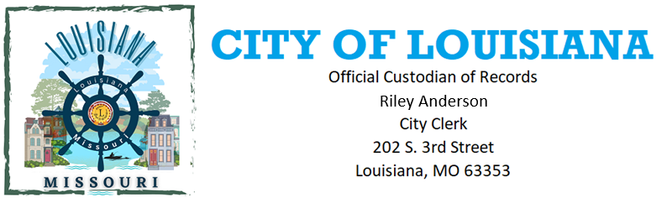
Records Request Form
This is a request for records under the Missouri Sunshine Law, Chapter 610, Revised Statues of Missouri.
I request that you make available to me the following records: (Describe the records as specifically as possible. Where you are asking for records that cover only a particular period, such as last year or a specific month, identify that time period)

If you know the subject matter of the records, but do not have additional information, use this alternative:
I request that you make available to me all records that relate to _________________________________
(Be as specific as possible; include dates if you can)

If you want and are willing to pay for copies of the records, rather than just being able to see them:
I request that the records responsive to my request be copied and sent to me at the following address:

If you believe your request serves the public interest, and is not just for personal or commercial interest you may ask that the fees be waived:
I request that all fees for locating and copying the records be waived. _____________________________
The information I obtain through this request will be used: (Tell how you will use the information and why that use is in the public)

Please let me know in advance if any search or copying if the fees will exceed $____________
(Insert amount you are willing to pay without additional information about the documents)

If portions of the requested records are closed, please segregate the closed portions and provide me with the rest of the records.

Name: ________________________
Address: _______________________
Phone: ________________________
Email Address: __________________

