
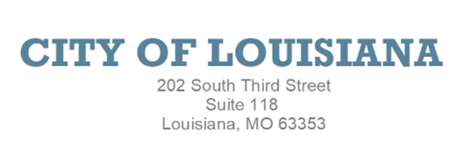
MERCHANT LICENSE APPLICATION
NEW-RENEWAL-UPDATES

PLEASE CHECK ONE: _____New License _____Renewal/Update _____No Longer Needed

Business Type: _________________________________________________________________
Business Name: ________________________________________________________________
Owner Name: __________________________________________________________________
Owner’s Phone Number: _________________________________________________________
Owner’s Email: ________________________________________________________________
Mailing Address: _______________________________________________________________
Business Address: ______________________________________________________________
Business Phone Number: _________________________________________________________
Business Email: ________________________________________________________________
FEIN or SSN: __________________________________________________________________
Person Updating Information: _____________________________________________________
Relationship With Company: ______________________________________________________

Signature: __________________________________________ Date: _________________
OFFICE USE ONLY
Annual License Fee: _________ Account Number: __________ License Month: ___________
MO Sec. of State Registered__________ MO Sales Tax Name & ID #___________________
Received By: _______________________

